E-Commerce Data Visualization Report
Power BI Dashboard Project
Project | E-Commerce Data Visualization
Dashboard File | E-Commerce Sales Dashboard.pbix
Dataset | e-commerce data.csv
Prepared By | Arshpreet Singh

Project Purpose: This report explains a Power BI dashboard created to analyze e-commerce sales, revenue trends, customer activity, product performance, and country-wise business contribution.

1. Introduction
This project converts raw e-commerce transaction data into an interactive Power BI dashboard. The dashboard gives a clear view of sales performance and helps users understand important business patterns.
The analysis focuses on revenue, order activity, products, customers, countries, and time-based sales trends.

2. Objective
The main objective is to create a visual dashboard that summarizes e-commerce performance in a simple and decision-friendly way.
- Analyze total sales and revenue performance.
- Identify top-performing products and countries.
- Study sales trends over time using invoice dates.
- Understand customer and order patterns.
- Present insights through clear Power BI visuals.

3. Dataset Description
The project uses the source file named e-commerce data.csv.
Column | Description
InvoiceNo | Invoice or order number.
StockCode | Product stock code.
Description | Product name or description.
Quantity | Number of units sold.
InvoiceDate | Date and time of transaction.
UnitPrice | Price of one unit.
CustomerID | Customer identifier.
Country | Country of the customer.

4. Data Cleaning And Preparation
The dataset was prepared before visualization so the dashboard could focus on meaningful sales activity.
- Reviewed transaction fields and data types.
- Checked quantity and unit price values.
- Filtered invalid or non-useful records where required.
- Used InvoiceDate for trend analysis.
- Calculated revenue from quantity and unit price.
Revenue Formula: Revenue = Quantity x UnitPrice

5. Dashboard Design
The dashboard was created in Microsoft Power BI and saved as E-Commerce Sales Dashboard.pbix.
- KPI cards for key sales metrics.
- Line charts for revenue trends.
- Bar charts for product and country comparison.
- Interactive filters and slicers.
- Dashboard screenshots stored in the SCREENSHOTS folder.

6. Key Insights
- Revenue performance can be monitored across different time periods.
- Top countries can be compared using country-wise sales visuals.
- High-performing products can be identified from product-level charts.
- Customer and invoice fields support order behavior analysis.
- Trend visuals make seasonal or changing sales patterns easier to understand.

7. Business Usefulness
This dashboard can support business decisions by making sales data easier to read, compare, and monitor.
- Track overall sales and revenue.
- Find strong and weak product areas.
- Understand which countries contribute major sales.
- Support inventory, marketing, and sales planning.

8. Tools And Technologies
- Microsoft Power BI
- CSV data source
- Data cleaning and transformation
- Data visualization and dashboard design

9. Conclusion
The E-Commerce Data Visualization project successfully presents raw transaction data as a clear Power BI dashboard. It provides a useful summary of revenue, products, customers, countries, and sales trends.
The project shows how data visualization can turn a large dataset into practical business insights.

10. Author
Arshpreet Singh

11. Dashboard Screenshots
The following screenshots show the Power BI dashboard views created for the e-commerce data visualization project.

Screenshot 1
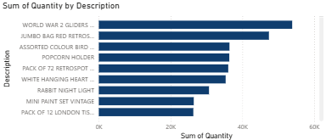
Figure 1: Product quantity analysis. This horizontal bar chart ranks the highest-selling products by total quantity sold, showing that items such as WORLD WAR 2 GLIDERS and JUMBO BAG RED RETROSPOT are among the leading products.

Screenshot 2
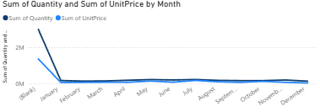
Figure 2: Monthly sales trend. This line chart compares total quantity and total unit price by month, highlighting a strong early sales peak followed by steadier activity across the remaining months.

Screenshot 3
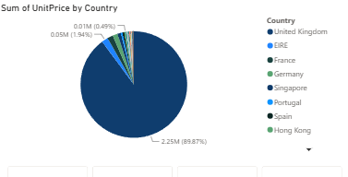
Figure 3: Country-wise sales contribution. This pie chart shows that the United Kingdom contributes the largest share of sales, with smaller portions coming from countries such as EIRE, France, Germany, Singapore, Portugal, Spain, and Hong Kong.

Screenshot 4
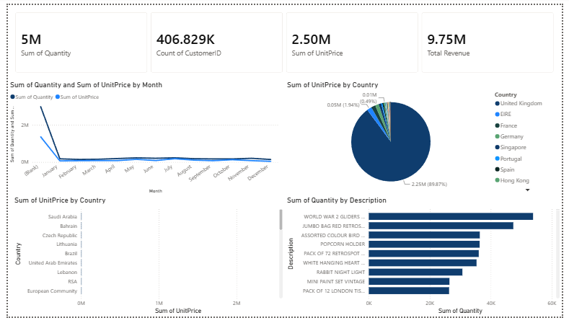
Figure 4: Complete Power BI dashboard overview. This full dashboard view combines KPI cards, monthly trend analysis, country-wise sales distribution, and product quantity ranking to provide a single summary of e-commerce performance.

Screenshot 5

Figure 5: Key performance indicators. These cards summarize the main dashboard metrics, including total quantity, customer count, sum of unit price, and total revenue.

Screenshot 6
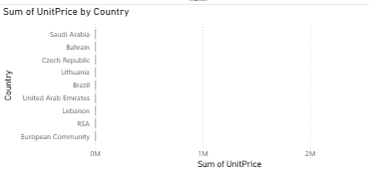
Figure 6: Country comparison by unit price. This bar chart compares unit price totals across selected countries and helps identify smaller country-level contributions outside the main sales market.

